***Home Page***

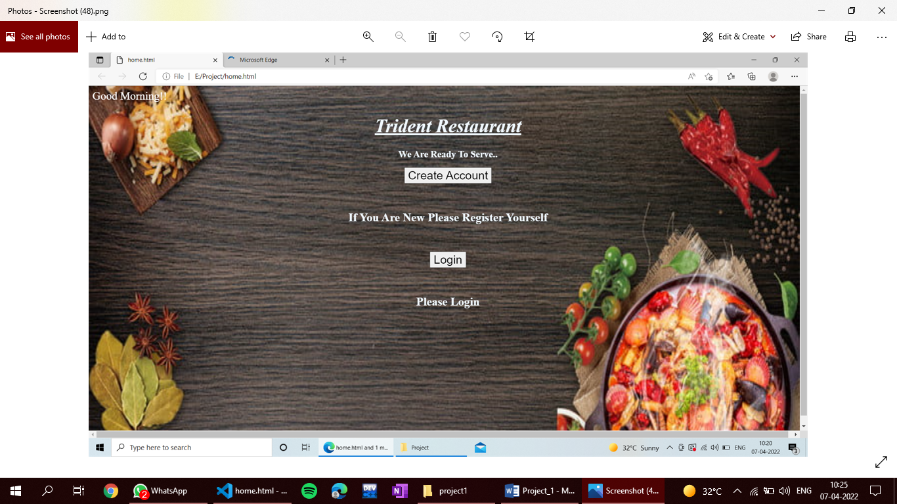

<html>

<head>

<style>

body{background-image: url("img1.jpg");

background-size: 100% 100%;}

body{width:100%;

height:100%;

background-position:center center;

background-repeat:no-repeat;

backface-visibility:hidden;

animation: slideBg 12s linear infinite 0s;

animation-timing-function: ease-in-out;

background-image: url("img1.jpg");

}

@keyframes *slideBg* {

0% {

     background-image: url("img1.jpg");

   }

25% {

     background-image: url("img2.jpg");

    }

50% {

     background-image: url("img3.jpg");

    }

75% {

     background-image: url("img4.jpg");

    }

100% {

     background-image: url("img5.jpg");

    }

100% {

     background-image: url("img6.jpg");

    }

}

h1{color:aliceblue;}

u{color:aliceblue;}

h2{color:aliceblue;

font-size:20;}

a{color:black;

text-decoration:none;}

div{background-color:aliceblue;}

button{

  font-size: 25;

  text-align:center;

  color:aliceblue;

}

h6{color:aliceblue;

text-align:center;

font-size:25;}

#a{

  font-size: 25;

  text-align:center;

  color:aliceblue;

}

h1{font-size:40;}

</style>

</head>

<script type="text/javascript">

document.write("<font size=+4 style='color: white;'>");

var day=new Date();

var hours=day.getHours();

if (hours>=0&&hours<12) {

document.write("Good Morning!!");

} else if (hours==12) {

document.write("Good Afternoon!!");

} else if (hours>=12&&hours<=17) {

document.write("Good Afternoon!!");

}

else {

document.write("Good Evening");

}

</script>

<body>

<center><i><u><h1>Trident Restaurant</h1></u></i></center>

<center><h2>We Are Ready To Serve..</h2></center>

<center><button><a href="signin.html">Create Account</a></button></center>

<center><h6>If You Are New Please Register Yourself</h6></center>

<center><button id="a"><a href="Login.html">Login</a></button></center>

<center><h6>Please Login</h6></center>

</body>

</html>

***Log IN page***

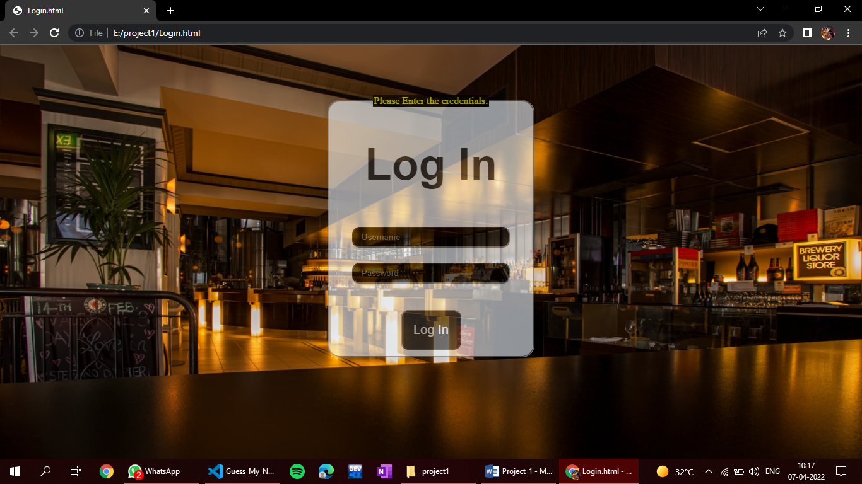

<html>

  <style>

    fieldset{

      display: block;

      background-color: aliceblue;

      opacity: 0.6;

      width: 300px;

      text-align: center;

      margin: auto;

      border-radius: 20px;

    }

    legend {

      background-color: black;

      color: yellow;

    }

    h1 {

      font-size: 70px;

      color: rgb(0, 0, 0);

      text-align: center;

      opacity: 0.8;

    }

    body {

      text-align: center;

    }

    button {

      color: rgb(255, 255, 255);

      margin-top: 30px;

      padding: 18px 18px 18px;

      font-size: 20px;

      margin-top: 30px;

      border-radius: 12px;

      opacity: 0.8;

      background-color: rgb(0, 0, 0);

    }

    input[type="text"] {

      width: 18%;

      padding: 7px 13px;

      margin: 12px 0;

      box-sizing: border-box;

      border-radius: 12px;

      opacity: 1px;

      color: rgb(255, 31, 1);

      background-color: rgb(0, 0, 0);

      width: 250px;

    }

    input[type="password"] {

      width: 18%;

      padding: 7px 13px;

      margin: 12px 0;

      box-sizing: border-box;

      border-radius: 12px;

      opacity: 1px;

      background-color: rgb(0, 0, 0);

      width: 250px;

      color: rgb(255, 31, 1);

    }

    body {

      background-image: url('pexels-pixabay-260922.jpg');

      background-repeat: no-repeat;

      background-size: 100% 100%;

}

  </style>

  <body>

    <!do not forget that in forms how you style see line number 24>

    <br><br><br><br>

    <form>

      <fieldset>

        <legend>Please Enter the credentials:</legend>

        <h1 style="font-family: sans-serif;">Log In</h1>

        <!--make log in cursive -->

      <input type="text" id="username" placeholder="Username" required /> <br />

      <input type="password" id="password" placeholder="Password" /> <br />

      <button onclick="hello()">Log In</button>

    </fieldset>

    </form>

  </body>

</html>

<script>

  function hello() {

    var hi = document.getElementById("username").value;

    var hello = document.getElementById("password").value;

    if (hi != hello) {

      alert("Log in Succesful ");

    } else if (hi == hello) {

      alert("Log in Unsuccessful ");

    }

  }

</script>

***Sign IN page***

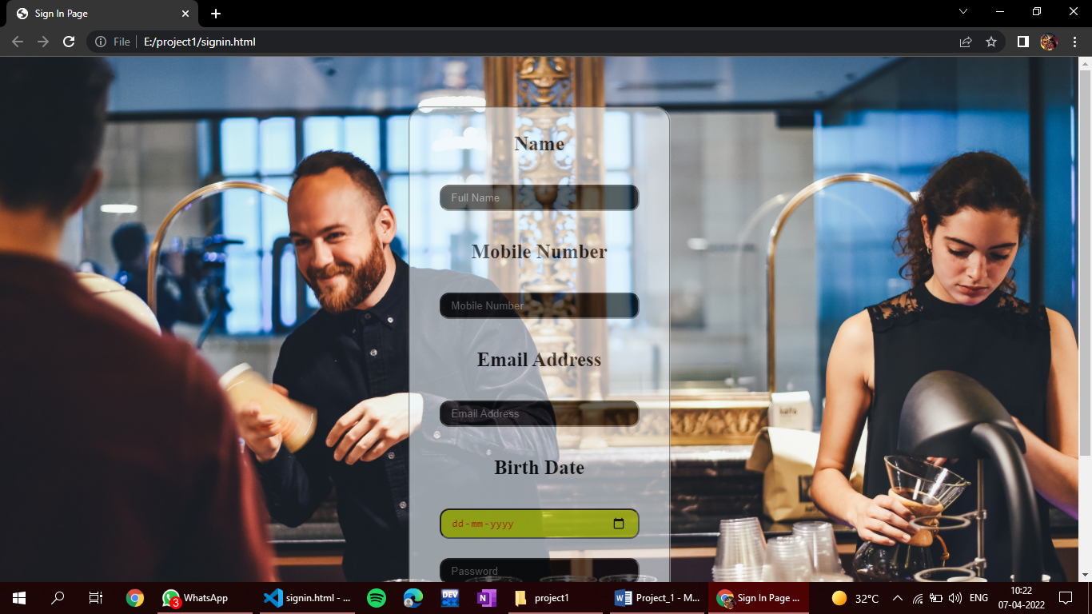

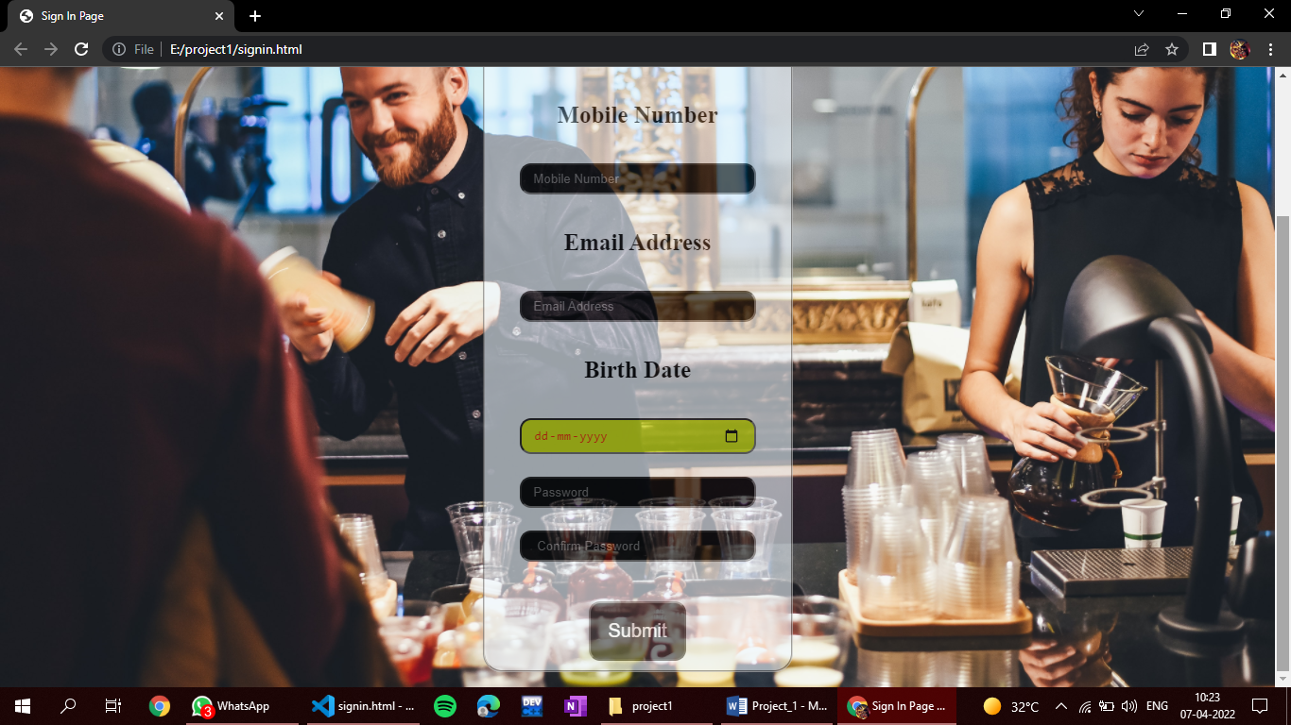

<html>

  <style>

    fieldset{

      display: block;­­­

      background-color: aliceblue;

      opacity: 0.6;

      width: 300px;

      text-align: center;

      margin: auto;

      border-radius: 20px;

    }

    legend {

      background-color: black;

      color: yellow;

    }

    h1 {

      font-size: 70px;

      color: rgb(0, 0, 0);

      text-align: center;

      opacity: 0.8;

    }

    body {

      text-align: center;

    }

    input[type="submit"] {

      color: rgb(255, 255, 255);

      margin-top: 30px;

      padding: 18px 18px 18px;

      font-size: 20px;

      margin-top: 30px;

      border-radius: 12px;

      opacity: 0.8;

      background-color: rgb(0, 0, 0);

    }

    input[type="text"] {

      width: 18%;

      padding: 7px 13px;

      margin: 12px 0;

      box-sizing: border-box;

      border-radius: 12px;

      opacity: 1px;

      color: rgb(255, 31, 1);

      background-color: rgb(0, 0, 0);

      width: 250px;

    }

    input[type="number"] {

      width: 18%;

      padding: 7px 13px;

      margin: 12px 0;

      box-sizing: border-box;

      border-radius: 12px;

      opacity: 1px;

      color: rgb(255, 31, 1);

      background-color: rgb(0, 0, 0);

      width: 250px;

    }

    input[type="email"] {

      width: 18%;

      padding: 7px 13px;

      margin: 12px 0;

      box-sizing: border-box;

      border-radius: 12px;

      opacity: 1px;

      color: rgb(255, 31, 1);

      background-color: rgb(0, 0, 0);

      width: 250px;

    }

    input[type="date"] {

      width: 18%;

      padding: 7px 13px;

      margin: 12px 0;

      box-sizing: border-box;

      border-radius: 12px;

      opacity: 1px;

      color: rgb(255, 31, 1);

      background-color: rgb(222, 245, 13);

      width: 250px;

    }

    input[type="password"] {

      width: 18%;

      padding: 7px 13px;

      margin: 12px 0;

      box-sizing: border-box;

      border-radius: 12px;

      opacity: 1px;

      background-color: rgb(0, 0, 0);

      width: 250px;

      color: rgb(255, 31, 1);

    }

    body {

      background-image: url('crew-szCvt1gP2d4-unsplash.jpg');

      background-repeat: no-repeat;

      background-size: 100% 100%;

}

h3{

  font-size: 25;

}

  </style>

<head><title>Sign In Page</title></head>

<script src="https://ajax.googleapis.com/ajax/libs/angularjs/1.8.2/angular.min.js"></script>

<body ng-app="myapp" ng-controller="ctrl">

<form id="my" name="myform" ng-submit="save1(this)">

<h1><u><b></u></b></h1>

<br><br><br>

<fieldset>

<h3>Name</h3>

<input type="text" placeholder="Full Name" name="name" ng-model="name1" ng-required="true">

<span ng-show="myform.name.$dirty&&myform.name.$invalid"></span>

<span ng-show="myform.name.$error.required"></span><br>

<h3>Mobile Number</h3>

<input type="number" placeholder="Mobile Number" name="number" ng-model="number" ng-minlength="10" ng-maxlength="10" ng-required="true">

<span ng-show="myform.number.$dirty&&myform.number.$invalid"></span>

<span ng-show="myform.number.$error.required"></span><br>

<h3>Email Address</h3>

<input type="email" placeholder="Email Address"  name="email" ng-model="email5" ng-required="true">

<span ng-show="myform.email.$dirty&&myform.email.$invalid"></span>

<span ng-show="myform.email.$error.required"></span><br>

<h3>Birth Date</h3>

<input type="date" placeholder="Birth Date" name="date1" ng-model="date1" ng-required="true">

<span ng-show="myform.date1.$dirty&&myform.date1.$invalid">Invalid Date</span>

<span ng-show="myform.date1.$error.required"></span><br>

<input type="password" id="password" placeholder="Password" /> <br />

<input type="password" id="Cpassword" placeholder=" Confirm Password" /> <br />

<!--Terms And Condtitions-->

<input type="submit"  name="submit" value="Submit">

</form>

</fieldset>

<script>

var app=angular.module("myapp",[]);

app.controller('ctrl',function(*$scope*){

$scope.save1=function(*$this*){

if($this.myform.number.$error.minlength){

alert("Invalid Mobile Number");

} else if($this.myform.email.$error.required){

alert("Please Enter Email Address");

}

else if($this.myform.name.$error.required){

alert("Please Enter Full Name");

}

else if($this.myform.date1.$error.required){

alert("Birth Date Is Mandatory");

}

else if($this.myform.date1.$error.$invalid){

alert("Invalid Date");

}

else {

alert("Successfully Registered");

}

}

});

</script>

</body>

</html>

Guess my Number game

<!DOCTYPE html>

<html>

  <head>

    <title>Guess_a_Number_And_Win</title>

    <style>

      body {

        text-align: center;

        background-color: orangered;

        font-size: 20px;

        font-family: sans-serif;

      }

      #container {

        background-color: ;

        border: 5px solid

        height: 275px;

        margin: auto;

        text-align: center;

      }

      p{

        color:;

      }

    </style>

  </head>

<body>

<div id = "container">

  <br> <br> <br> <br> <br>  <br> <br>  <br> <br> <br>

  <p>FREE COUPONS !!!</p>

  <p>Guess A number between 1-100 </p>

  <p id = "outputt"> Enter a NUMBER below </p>

  <input type="text" id = "userInput">

  <button id="btn"> Guess !!</button>

</div>

<script>

  let btn = document.getElementById('btn');

  let output = document.getElementById('outputt');

  let number = [Math.floor(Math.random() * 100)]

  btn.addEventListener('click' , function(){

  let input = document.getElementById('userInput').value;

  if (input == number){

    output.innerHTML = 'Yay!! Your Coupon Number is #12WERFT^& $(number)'

  }else if (input < number){

    output.innerHTML = 'Oops!! you guessed a bit LOW!!! '

  }

  if (input > number){

    output.innerHTML = 'Oops!! you guessed a bit HIGH !!! '

  }

  });

    </script>

</body>

</html>